Clonreher Castle

There is a story of disinheritance relating to a branch of the O’Dunnes told by Daniel O’Byrne (ca.1804-1882) in his History of the Queen’s County (1856). The scene of this particular O’Dunne family feud was the Castle of Clonreher, situated some two miles outside Portlaoise on the Mountrath Road. The complex includes a ruined tower house and an eighteenth century five bay house of three floors. The house was almost certainly constructed out of the castle’s bawn walls.

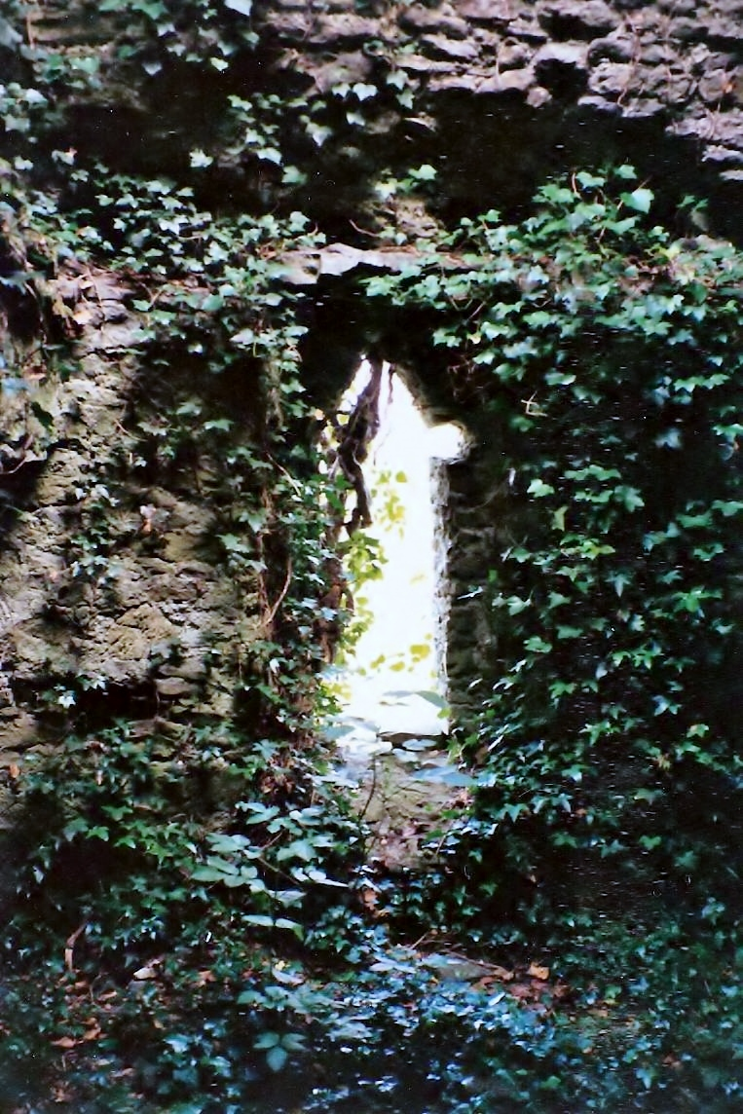

The castle originally belonged to the O’Dowlng clan, but during the reign of Queen Mary Tudor (r.1553-1558) it was granted to John Dunkirley, a soldier, who also held land around Fort Protector in Maryborough (Portlaoise). Clonreher was a defensive outpost of Fort Protector, as was Ballyknocken Castle; intended to defend the new Tudor settlers in what had been O’Moore’s Country, but now shirred and renamed Queen’s County in honour of Mary Tudor. By 1549 Clonreher was in the hands of Sir Ralph Bagnall. Judging by the alternative name of the place, Merrickstown, it must have been tenanted in either John Dunkirley or Sir Ralph’s time by a settler family surnamed Merrick. Canon O’Hanlon’s History of the Queen’s County records a grant to Robert Hartpole in 1576 ‘of the ruinous castle and land of Clonreher, alias Merrickstown.’ Probably ruinous because it had suffered in the struggle for supremacy between the Cosbys and O’Moores for what is now Co. Laois. However, the Dunkirleys must have retained a claim upon it as in 1562 the castle and lands of Clonreher were granted to John Dunkirley, almost certainly a son of the previous John Dunkirley. In 1628, Sir Pierce Crosby was successful in petitioning Charles I to grant him the castle, town and lands of Clonreher.

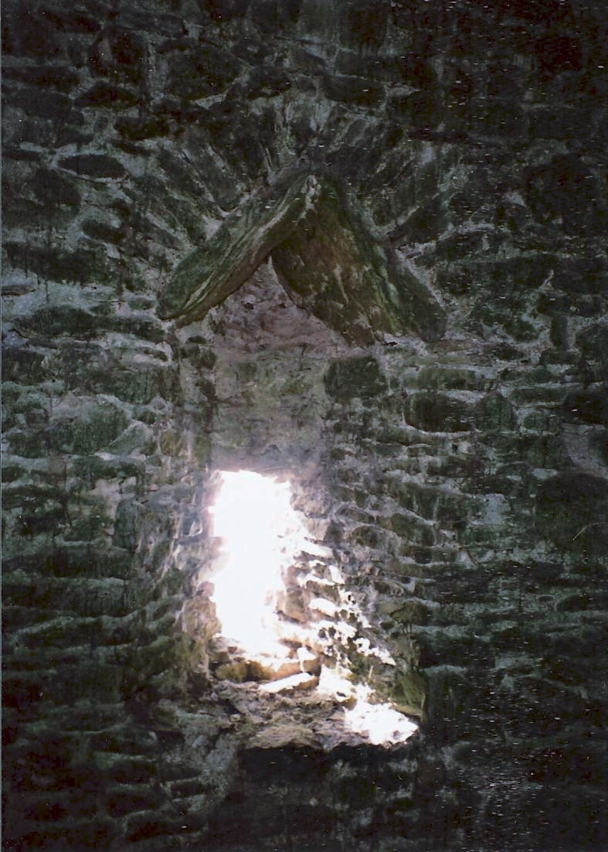

Following Cromwell’s victory in the English Civil War and the War of the Irish Confederacy, Clonreher
Castle was “slighted” or rendered indefensible in 1656 by Commonwealth officers, Hewson and Reynolds, and the lands confiscated by Parliament. With the restoration of the Stuart monarchy, Charles II granted Clonreher to Thomas Dongan, Earl of Limerick (1634–1715) in 1670. Dongan, Governor of New York under Charles II and James II, forfeited Clonreher together with his many estates, in 1692 for his support of James II. At Clonreher, some 279 acres were retained by the Williamite government to be counted among lands granted to army officers who had served in William’s Irish campaign.

Irish lands confiscated under William III were not distributed until 1703. The Dunnes are unlikely to have settled there before that year. Daniel O’Byrne said that this branch of the O’Dunne clan were descendants of a chieftain named ‘Con O’Dunne.’ O’Byrne in his History gives the tradition that Con O’Dunne escaped from the Massacre of Mullaghmast in 1577, in the company of Rory O’Moore. He says that following this Con O’Dunne was known by the name of Con-Raha, meaning ‘Con of the Race’ and that his descendants were known as ‘Conrahy.’ Upton, in his notes on the O’Dunnes in O’Hanlon’s History, remarks that the heads of minor ‘O’Doyne’ families were called ‘Canfynny.’ O’Byrne also attributes the construction of the castle to Con O’Dunne, but this is unlikely.

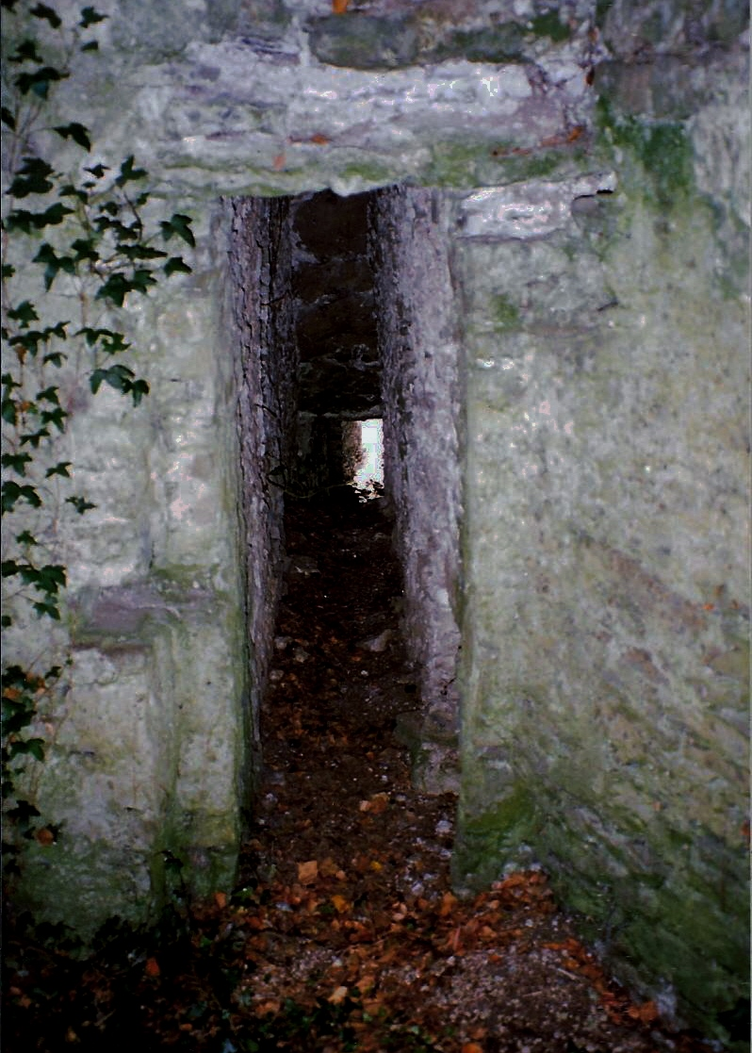

The family legend as recorded by O’Byrne was that the O’Dunnes owned the property. He goes on to say that the last member of the Dunnes who possessed Clonreher was ‘married to a lady of remarkable beauty.’ However, he does not give this couple’s first names, although he does record the names of their three daughters: Catherine, Winifred and Sarah. Their father he said, Mr. Dunne, had a secret mistress, a servant in the castle, who bore him a son and after his wife died the master of Clonreher married, in O’Byrne’s words, ‘his doxy’ and so made the son legitimate. After his father died the son confirmed to the Established Church and thereby invoking the penal laws - he succeeded in disinheriting his three half-sisters from Clonreher and the six townlands associated with the castle. The Dunne sisters married into ‘respectable’ farming families with gentry connections. Catherine Dunne married into the Conways, Winifred Dunne to the Dalys and Sarah Dunne to the Mihens. Although O’Byrne does not date these events, they are associated with the introduction of the penal laws in 1703.

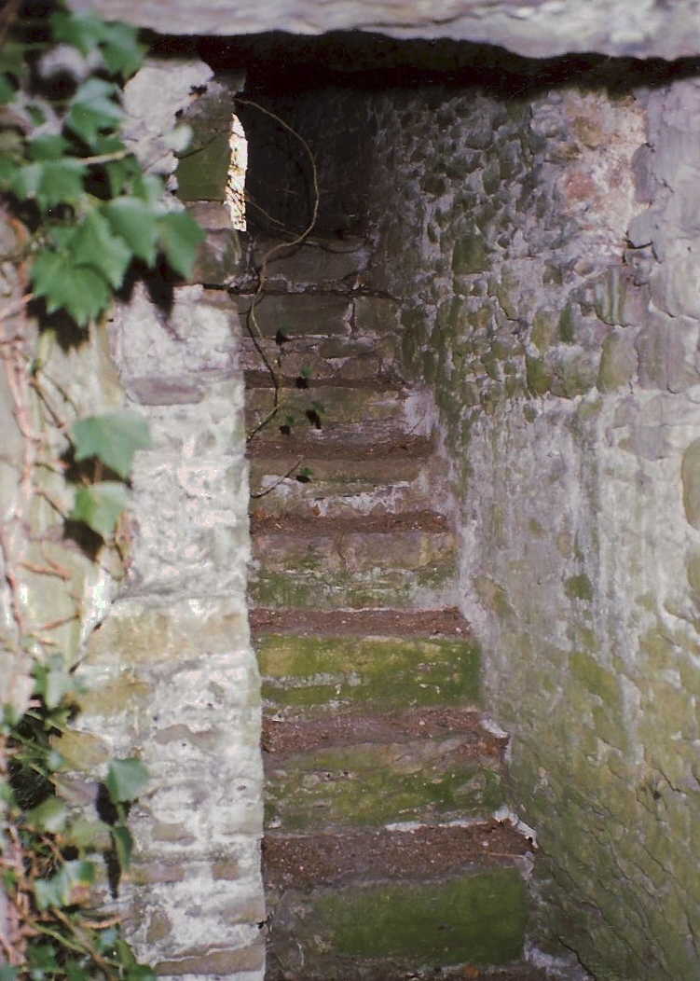

If O'Byrne's account is correct then it must also be assumed that the young un-named Dunne who inherited, quickly sold the property, because in 1730 John Kelly, gentleman, died in possession of Clonreher and willed the place to his son, John Kelly junior. The gentleman’s residence at Clonreher was almost certainly constructed by the Kellys. John Kelly the younger’s will was proved in 1758. Benjamin Bunbury (d.1765), son of Mathew Bunbury of Kilfeacle, married Mary Kelly, daughter of John Kelly of Clonreher in 1724. Benjamin and Mary Bunbury had three sons - Matthew, Benjamin and Joseph, and four daughters - Elizabeth, Anne, Hannah and Diana (and possibly Harriet who married Henry Irvine). Matthew Bunbury was disinherited by his father and the other sons died young, and so upon Benjamin Bunbury’s death in 1765, the Kilfeacle estate was left to his eldest daughter, Elizabeth Richardson.
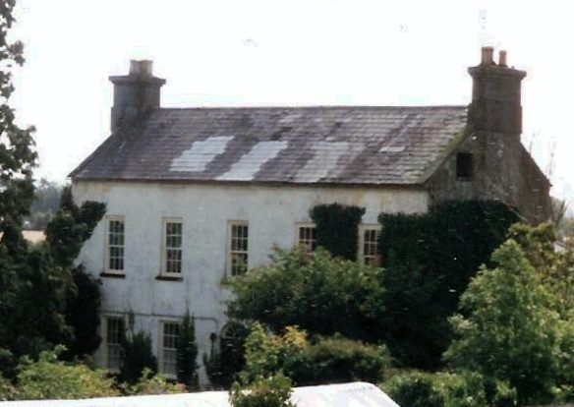

Catherine Dunne who married - Conway had three sons who died unmarried and a daughter Mary Conway who married Martin Kelly of Garryglass, another ‘respectable farmer’ according to O’Byrne’s account. On his mother’s side Martin Kelly claimed a descent from the O’Dunnes of Dooregan. Their daughter, Margaret Kelly, married Walter Byrne. Margaret and Walter were the parents of the Daniel O’Byrne who recorded the Dunne/Clonreher family tradition. Margaret and Walter are buried in the graveyard at Fossey, near Timahoe, under a commemorative memorial stone where her descent from Con O’Dunne is again stated. She was born in 1770 and died in 1847.

One possible explanation for O’Byrnes tale but the absence of a Dunne at Clonreher seems possible. As Daniel O’Byrne (1804-1882) claimed descent from the Dunnes of Clonreher through his mother Margaret Kelly (1770-1847), her father, as stated, was Martin Kelly of Garryglass who claimed a maternal descent from the O’Dunnes of Dooregan. It may well be that there were never Dunnes at Clonreher, but rather, that their name had become tagged to Clonreher by mistake and that the whole story, or at least parts, should apply to the Kellys of Clonreher. It seems likely that Martin Kelly of Garryglass, whose daughter was born in 1770, was a descendent of the John Kelly, gentleman, of Clonreher, who died in 1730, and that the family traditions of the Kellys and Dunnes had become hopelessly confused by the time O’Byrne heard them.

As for the stories of disinheritance, there may have been some memory of Matthew Bunbury’s disinheritance, who was connected to Clonreher through his mother, Mary Kelly, but disinheritance and the memory of a family member confirming to the Established Church was very much the family theme of the O’Dunnes of Dooregan. It is not difficult to conclude that a marriage connection between the Kelly and O’Dunnes brought about a merging and mixing of their family traditions, which is reflected in O’Byrne’s account.
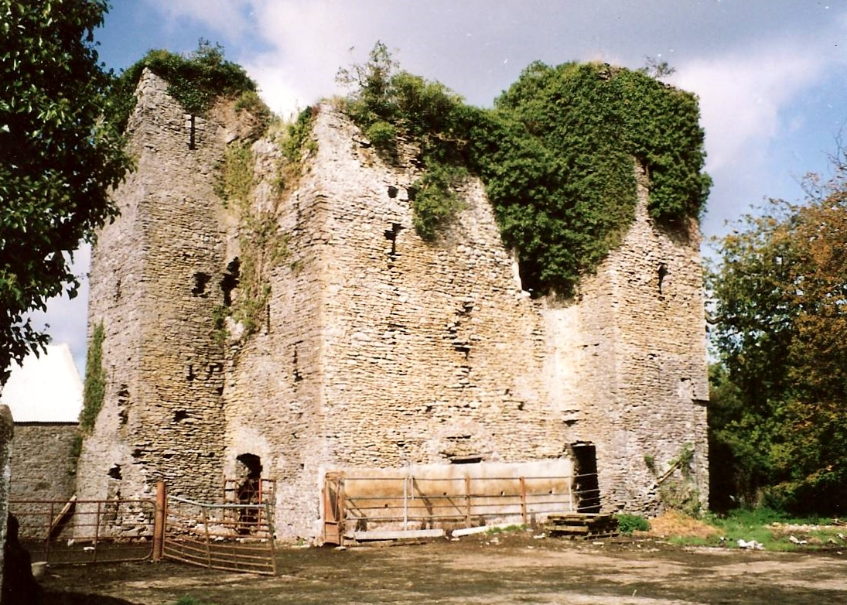

Nevertheless, the story of Laois is richer for O’Byrne’s recording of oral histories, and some gratitude is owned to him, even if there is some reliance upon written records to disentangle these tales, O’Byrne at least left us the flesh upon the bones. However, as a final word to this attempt at deconstruction and reconstruction - it would only take a single document dated between 1703 and 1723 to show there was after all a Dunne at Clonreher to vindicate the O’Byrne account in the fact as well as the spirit.

Daniel Byrne-Rothwell, 17 December 2012.

